Frequencies for Categorical Data

The Frequencies procedure can produce summary measures for categorical variables in the form of frequency tables, bar charts, or pie charts.

To run the Frequencies procedure, click **Analyze > Descriptive Statistics > Frequencies**.

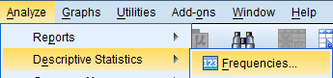

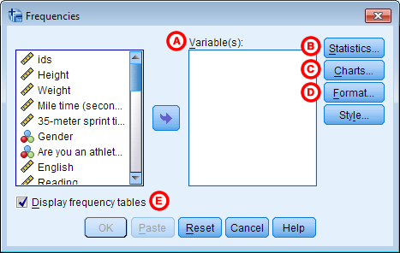

**A** **Variable(s):** The variables to produce Frequencies output for. To include a variable for analysis, double-click on its name to move it to the Variables box. Moving several variables to this box will create several frequency tables at once.

**B** **Statistics:**Opens the Frequencies: Statistics window, which contains various descriptive statistics.

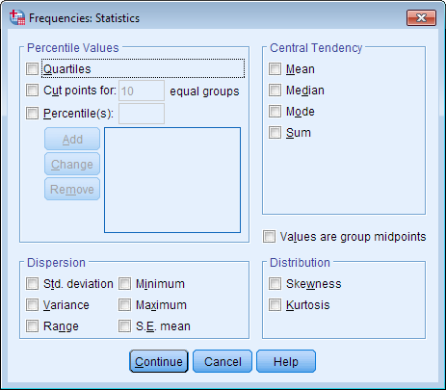

The vast majority of the descriptive statistics available in the Frequencies: Statistics window are never appropriate for nominal variables, and are rarely appropriate for ordinal variables in most situations. There are two exceptions to this:

* The **Mode** (which is the most frequent response) has a clear interpretation when applied to most nominal and ordinal categorical variables.
* The **Values are group midpoints** option can be applied to certain ordinal variables that have been coded in such a way that their value takes on the midpoint of a range. For example, this would be the case if you had measured subjects' ages and had coded anyone between the ages of 20 and 29 as 25, or between the 30 and 39 as 35 (source: [IBM SPSS Statistics Information Center](http://publib.boulder.ibm.com/infocenter/spssstat/v20r0m0/index.jsp?topic=%2Fcom.ibm.spss.statistics.help%2Fidh_freq_stat.htm)).

If your categorical variables are coded numerically, it is very easy to mis-use measures like the mean and standard deviation. SPSS will compute those statistics if they are requested, regardless of whether or not they are meaningful. It is up to the researcher to determine if these measures are appropriate for their data. In general, you should never use any of these statistics for dichotomous variables or nominal variables, and should only use these statistics with caution for ordinal variables.

**C** **Charts:**Opens the Frequencies: Charts window, which contains various graphical options. Options include bar charts, pie charts, and histograms. For categorical variables, bar charts and pie charts are appropriate. Histograms should only be used for continuous variables; they should *not* be used for ordinal variables, and should *never* be used with nominal variables.

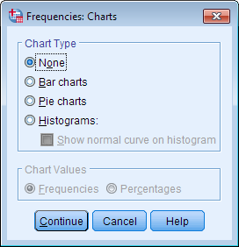

* **Bar chart** displays the categories on the graph's x-axis, and either the frequencies or the percentages on the y-axis
* **Pie chart** depicts the categories of a variable as "slices" of a circular "pie".

Note that the options in the **Chart Values** area apply only to bar charts and pie charts. In particular, these options affect whether the labeling for the pie slices or the y-axis of the bar chart uses counts or percentages. This setting will greyed out if Histograms is selected.

**D** **Format:** Opens the Frequencies: Format window, which contains options for how to sort and organize the table output.

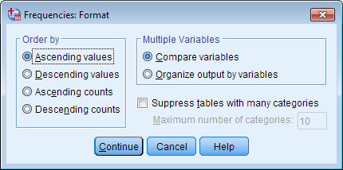

The **Order by** options affect only categorical variables:

* **Ascending values** arranges the rows of the frequency table in increasing order with respect to the category values: (alphabetically if string, or by numeric code if numeric)
* **Descending values** arranges the rows of the frequency table in decreasing order with respect to the category values.
  + Note: If your categorical variable is coded numerically as 0, 1, 2, ..., sorting by ascending or descending value will arrange the rows with respect to the numeric code, **not** with respect to any assigned labels.)
* **Ascending counts**orders the rows of the frequency table from least frequent (lowest count) to most frequent (highest count).
* **Descending** **counts** orders the rows of the frequency table from most frequent (highest count) to least frequent (lowest count).

When working with two or more categorical variables, the **Multiple Variables** options only affects the order of the output. If **Compare variables** is selected, then the frequency tables for all of the variables will appear first, and all of the graphs for the variables will appear after. If **Organize output by variables** is selected, then the frequency table and graph for the first variable will appear together; then the frequency table and graph for the second variable will appear together; etc.

**E** **Display frequency tables**: When checked, frequency tables will be printed. (This box is checked by default.) If this check box is not checked, no frequency tables will be produced, and the only output will come from supplementary options from **Statistics** or **Charts**. **For categorical variables, you will usually want to leave this box checked**.

Example: Summarizing a Categorical Variable

Using the sample dataset, let's a create a frequency table and a corresponding bar chart for the class rank (variable *Rank*), and let's also request the Mode statistic for this variable.

RUNNING THE PROCEDURE

USING THE FREQUENCIES DIALOG WINDOW

1. Open the Frequencies window (**Analyze > Descriptive Statistics > Frequencies**) and double-click on variable *Rank*.
2. To request the mode statistic, click **Statistics**. Check the box next to **Mode**, then click **Continue**.
3. To turn on the bar chart option, click **Charts**. Select the radio button for **Bar Charts**. Then click **Continue**.
4. When finished, click **OK**.

USING SYNTAX

**FREQUENCIES VARIABLES=Rank**

**/STATISTICS=MODE**

**/BARCHART FREQ**

**/ORDER=ANALYSIS.**

OUTPUT

Two tables appear in the output: **Statistics**, which reports the number of missing and nonmissing observations in the dataset, plus any requested statistics; and the frequency table for variable *Rank*. The table title for the frequency table is determined by the variable's label (or the variable name, if a label is not assigned).

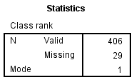

Here, the Statistics table shows that there are 406 valid and 29 missing values. It also shows the Mode statistic: here, the mode value is "1", which is the numeric code for the category Freshman. Notice that the Mode statistic isn't displaying the value labels, even though they have been assigned. (For this reason, we recommend not requesting the mode statistic; instead, determine the mode from the frequency table.)

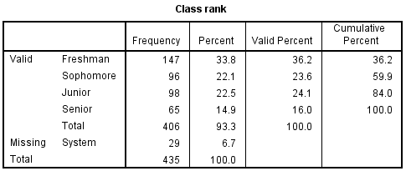

Notice how the rows are grouped into "Valid" and "Missing" sections. This grouping allows for easy comparison of missing versus nonmissing observations. Note that "System" missing responses are observations that use SPSS's default symbol  -- a period (.) -- for indicating missing values. If a user has assigned special codes for missing values in the Variable View window, those codes would appear here.

The frequency table contains four columns of summary measures:

* The **Frequency** column indicates how many observations fell into the given category.
  + The sample contained a total of 435 students. Of those students, 29 did not specify their class rank.
* The **Percent** column indicates the percentage of observations in that category out of all observations (both missing and nonmissing). You can verify the proportions for each group by dividing its count in the "frequency" column by the value in the last row of the table (435):
  + Freshman: 147/435 = 33.8%
  + Sophomore: 96/435 = 22.1%
  + Junior: 98/435 = 22.5%
  + Senior: 65/435 = 14.9%
  + Valid Total: 406/435 = 93.3%
  + Missing: 29/435 = 6.7%
* The **Valid Percent** column displays the percentage of observations in that category out of the total number of *nonmissing*responses. You can verify the proportions for each group by dividing its count in the "frequency" column by the value of "Total" that appears after the last valid category (406):
  + Freshman: 147/406 = 36.2%
  + Sophomore: 96/406 = 23.6%
  + Junior: 98/406 = 24.1%
  + Senior: 65/406 = 16.0%
* The **Cumulative Percent** column is the total percentage of the sample that has been accounted for up to that row; it can be computed by adding all of the numbers in the Valid Percent column above the current row:
  + Freshman: 36.2% (there are no rows before this one, so the first cumulative percent is identical to the first valid percent)
  + Sophomore: 36.2 + 23.6 = 59.8%
  + Junior: 36.2 + 23.6 + 24.1 = 83.9%
  + Senior: 32.6 + 23.6 + 24.1 + 16.0 = 100%

The bar chart appears after the tables.

